Weekly Chosun
(May 25, 2015 issue, 4 pages)
Korean National Major Weekly Magazine

[First Interview]
“North Korea Much Care and Investment to the Family Federation.
I have seen when is the best time to visit North Korea”

Head of Family Federation for World Peace and Unification Dr. Hak Ja Han Moon

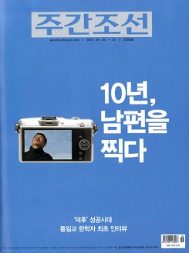
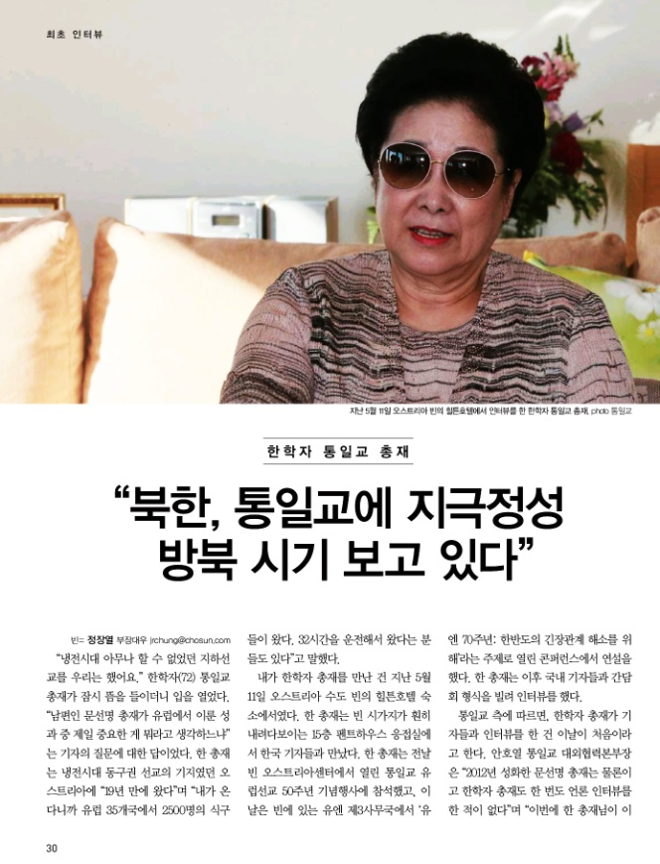
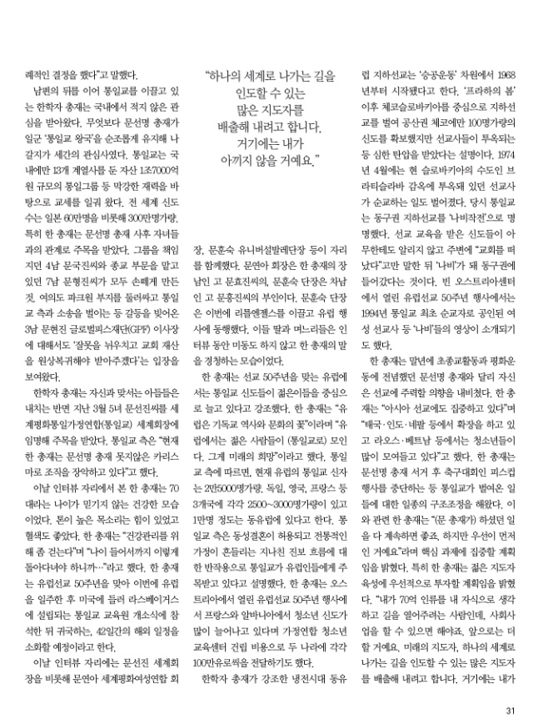

“We carried out underground evangelist activities when no one else could during the Cold War.” Head of Family Federation for World Peace and Unification (FFWPU) Dr. Hak Ja Han Moon (72) pauses for a beat before speaking. This was her answer to the reporter’s question as to what she regarded as her husband, Rev. Sun Myung Moon’s, biggest achievement in Europe. Dr. Han is visiting Austria, the location of the headquarters of Eastern European evangelism during the Cold War, for the “first time in 19 years.” She continued, “2,500 members gathered from 35 nations across Europe to come see me. Some people drove for 32 hours to attend our event.”

We met Dr. Hak Ja Han Moon at the Hilton Hotel in Vienna, Austria’s capital, on May 11th. She received Korean reporters in the penthouse sitting room on the 15th floor, which boasted a breathtaking view of the city. Dr. Han had previously attended the “50 Years of European Evangelism” event, which was held by the Family Federation at the Austria Center on the previous day. Before meeting us, she gave the keynote address at an international conference held at the UN Office in Vienna under the banner, “The UN at 70: Toward a Resolution of Tensions on the Korean Peninsula.” She then held a meeting with Korean reporters.

According to the Family Federation, this is the first interview conducted between Dr. Hak Ja Han Moon and the press. “Neither Rev. Sun Myung Moon, who passed away in 2012, nor Dr. Hak Ja Han Moon, has ever conducted a press interview,” said Public Relations Manager Ho-Yeul An. “The interview was an unexpected decision on the part of Dr. Han.”

Dr. Hak Ja Han Moon, who is continuing the work of her late husband in the Family Federation, has received a fair amount of attention in Korea. Many have been watching her to see whether she will be able to inherit and develop “the Kingdom of the Family Federation,” originally started by Rev. Sun Myung Moon. The Tongil Group maintains assets worth 1.7 trillion won and manages 13 subsidiary companies in Korea alone. The church is estimated to have about 3,000,000 members worldwide, including 600,000 members in Japan. Dr. Han has received notable attention for her relationship with her children since her husband’s death. She had her fourth son Kook Jin Moon, who had overseen Tongil Group, and her seventh son Hyung Jin Moon, who managed the religious aspect of the Church, step down from their positions. In regards to her third son Hyun Jin Moon, who is embroiled in a lawsuit with the Church for property in Yeouido and other various disputes, Dr. Han’s stance is she will accept after he repents for his mistakes and return the property to its rightful owner.

In contrast to Dr. Han’s treatment of her sons, this March, she appointed her fifth daughter Sun Jin Moon as the International President of FFWPU. “Dr. Han commands the organization with just as much charisma as her husband, Rev. Sun Myung Moon,” said a representative of the Family Federation.

When we met with her today, she looked astonishingly young and healthy for her 70 years. She spoke in a high, strong voice and shone with a healthy complexion. “I walk a bit to maintain my health,” she said. “I have to stay healthy because I plan to continue traveling even in my old age.” After touring Europe to celebrate 50 years of evangelism on the continent, Dr. Han plans to visit the United States to attend the opening ceremony of a Family Federation education center in Las Vegas. She will continue her 42-day world tour before returning to Korea.

Dr. Han was accompanied to her interview by Family Federation International President Sun Jin Moon, Women’s Federation for World Peace International President Yeon-Ah Moon, Universal Ballet Director Hoon-Sook Moon and others. President Yeon-Ah Moon is the wife of Dr. Han’s first son, the late Hyo Jin Moon, and General Director Hoon-Sook Moon is the wife of her second son, the late Heung Jin Moon. General Director Hoon-Sook Moon brought the Little Angels with her on this visit for performances in Europe. During the interview, Dr. Han’s daughter and daughters-in-law did not budge an inch, as they sat resolutely, listening quietly and courteously to her words.

Dr. Han said that the congregation of the European church, which is celebrating 50 years of evangelism, is growing in number, particularly among the young people. “Europe is the flower of Christian history and culture,” said Dr. Han. “Many young people flock to the [Family Federation] of Europe. That is my hope for the future.” According to the Family Federation, the congregation of the European church is about 25,000 people, with about 2,500 to 3,000 members each in Germany, England and France, and about 10,000 members in Eastern Europe. The church also explained that it was receiving attention in Europe for its views in opposition to same-sex marriage and other progressive ideas, which they regard as leading to the destruction of the traditional family. Dr. Han discovered at the “50 Years of European Evangelism” event that the congregation of young people was growing rapidly in both France and Albania. She donated 1,000,000 Euros to each nation to help build youth education centers for the Family Federation.

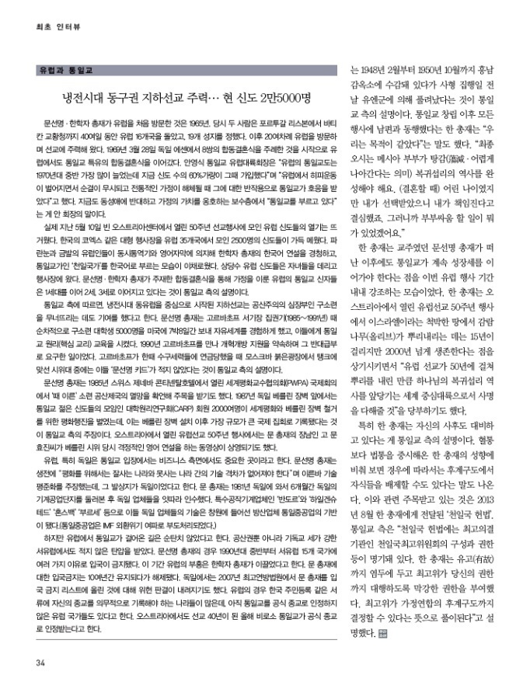
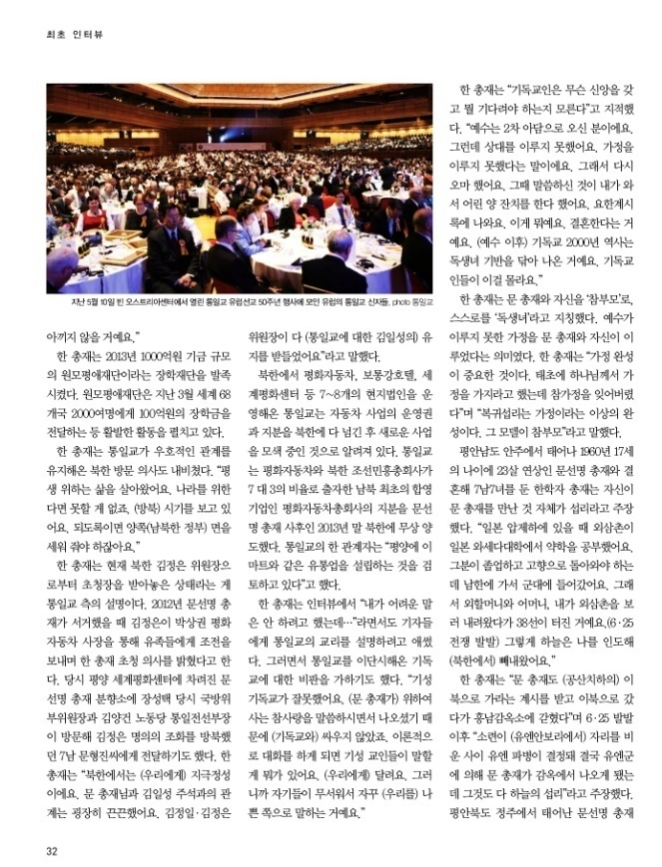

Dr. Han told us that the underground evangelist movement in Eastern Europe during the Cold War began with the “Victory over Communism” (VOC) movement in 1968. The underground evangelist movement began in earnest after “Prague Spring” in Czechoslovakia, and brought about 100 new members in the Czech Republic alone. Many of the evangelists, however, were imprisoned or faced with oppression. In April of 1974, one evangelist was even martyred in a prison in Bratislava in present-day Slovakia. The underground evangelist movement of the Family Federation at that time was dubbed “Operation Butterfly.” The members who had received training as evangelists worked in absolute secrecy. They told their loved ones simply that they had left the church, then becoming “butterflies” as they entered the Eastern Bloc. At the “50 Years of European Evangelism” event in Vienna at the Austria Center, a video was shown commemorating the Family Federation’s first martyred evangelist in 1994 and other evangelist “butterflies.”

In contrast to her husband, who focused strongly on interreligious and peace movements, Dr. Han hinted at focusing her strength in the autumn of her life on evangelism. “We are also focusing on evangelism in Asia right now,” she said. “We are expanding our congregation in Thailand, India, Nepal and other nations, and many young people are joining in Laos and Vietnam as well.” After Rev. Moon’s death, Dr. Han has measurably restructured the Family Federation by halting the Peace Cup and other enterprises. “Of course I would like to continue the work of my husband. However, first things come first,” she said as she explained her plan of focus. Dr. Han plans to concentrate on educating young leaders as a top priority. “I think of the seven billion people on earth as my children, and I need to open up a path for them. I hope to also be able to continue the social work if possible. I am working now to produce many new leaders of the future who can lead the world. I will spare no expense in this effort.”

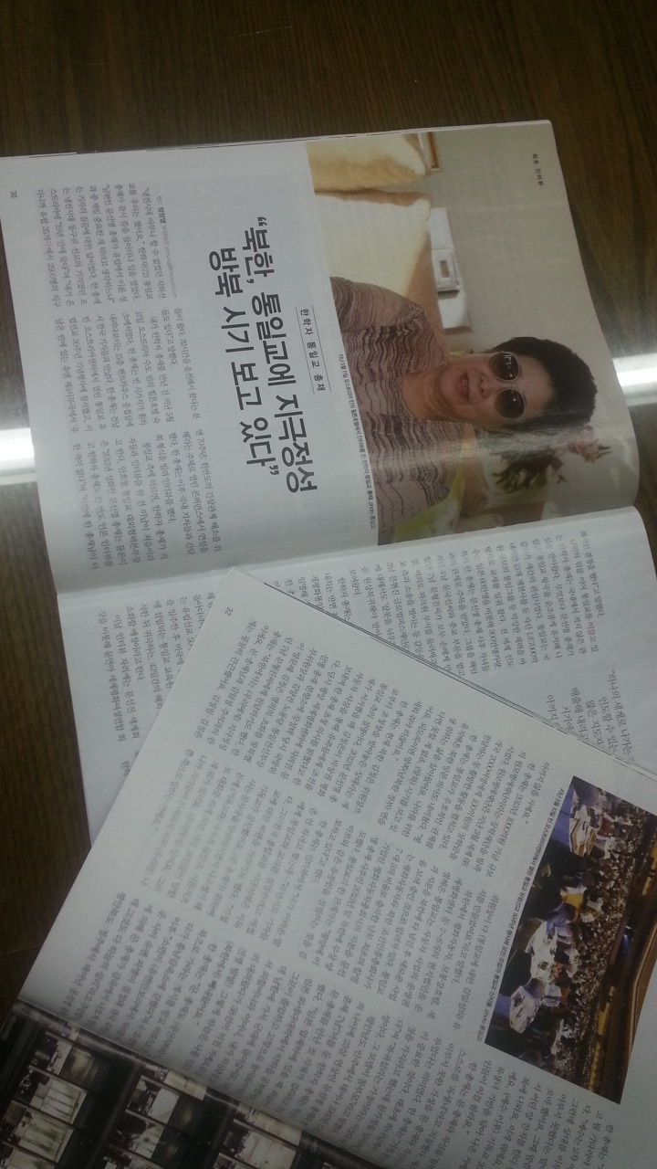

In 2013, Dr. Han founded the Wonmo Pyeongae Foundation, a scholarship foundation worth 100 billion won. The Foundation is very active, having carried out an event in March in which about 2,000 students from 68 nations were presented with 10 billion won in scholarships.

Dr. Han also hinted at plans to visit North Korea, a nation with which the Family Federation has maintained a friendly relationship. “I have lived my life for the sake of others. I can accomplish anything if I live for the sake of the nation. The time is approaching for a visit to [North Korea].”

The Family Federation explained that Dr. Han received an invitation to visit North Korea from Supreme Leader Kim Jong Un. In 2012, after the death of Rev. Sun Myung Moon, Kim Jong Un sent his condolences to the bereaved through Peace Motors President Sang-Kwon Park, along with an invitation for Dr. Han to visit North Korea. Then Vice Chairman of the National Defense Commission of North Korea Sung-Taek Jang and Workers’ Party of Korea Director of United Front Department Yang-Gon Kim visited an incense altar erected in honor of Rev. Sun Myung Moon at the World Peace Center in Pyeongyang, and Kim Jong Un sent flowers in condolence to Rev. Moon’s seventh son Hyung Jin Moon, who visited North Korea previously. “North Korea takes very good care of us. My husband had a very deep relationship with Premier Kim Il Sung. Kim Jong Il and Kim Jong Un have continued to respect the will [of late Kim Il Sung towards the Family Federation],” explained Dr. Han.

The Unification Movement manages about seven or eight local subsidiaries in North Korea, including Peace Motors, the Botonggang Hotel and the World Peace Center. After turning over management and shares to North Korea, they began searching for a new enterprise. The Family Federation turned over all shares of Peace Motors, the first equity joint venture between North and South Korea, and the North Korean Joseon Minheung Company over to North Korea after Rev. Moon’s death at the end of 2013. “We are looking into establishing a distribution company similar to E-Mart in Pyeongyang,” said a representative.

The Unification Movement manages about seven or eight local subsidiaries in North Korea, including Peace Motors, the Botonggang Hotel and the World Peace Center. After turning over management and shares to North Korea, they began searching for a new enterprise. The Unification Movement turned over all shares of Peace Motors, the first equity joint venture between North and South Korea, North Korean Joseon Minheung Company owned a 30% share and Peace Moters owned a 70% share. Peace Motors signed over their share to North Korea for free at the end of 2013, following Rev. Moon’s death. “We are looking into establishing a distribution company similar to E-Mart in Pyeongyang,” said a representative.

“I didn’t want to speak about difficult topics,” began Dr. Han in response to a question about the doctrine of the Family Federation. The Family Federation doctrine has largely been regarded as heresy by the Christian Church. “That is a mistake on the part of the Christian establishment. My husband emerged on the scene speaking of true love and living for the sake of others. He did not fight with the Christian Church. They cannot say anything against us from a theoretical standpoint. They are lacking in a theoretical standpoint compared to us. They came to fear us. That is why they continue to try to paint us in a bad light.”

“Christian people do not know what they should believe and what they are waiting for,” said Dr. Han. “Jesus came as the second Adam. However, he was unable to find a partner and begin a family. That is why he needed to come again. At that time, he said that he would come and hold the banquet of the lamb. It appears in the Book of Revelation. What does this refer to? It is referring to marriage. Over the course of 2,000 years, Christianity needed to lay the foundation for the begotten daughter of God. Christians are unaware of this fact.”

Dr. Han referred to herself as the “Only Begotten Daughter,” and to herself and her husband as the “True Parents,” with the implication that she and her husband established the family that Jesus was unable to create. “The completion of the family is crucial. At the beginning of time, God told man to establish families, but the true family was lost,” she said. “The providence of restoration is the completion of the ideal family. The True Parents fulfill the model of that ideal.”

Dr. Han, who was born in Anju, Pyeongannam-do, married Rev. Sun Myung Moon at the age of 17. She gave birth to seven sons and seven daughters by him. She considers her meeting Rev. Moon as a providential event. “When Korea was under Japanese rule, my uncle studied pharmacology at Waseda University. When he graduated, he was supposed to return to our hometown, but instead he entered the army in South Korea. When I went with my maternal grandmother and mother to visit him, the Korean War began, just after we crossed the 38th parallel. Heaven led me out of North Korea.”

“My husband received a revelation to go to North Korea, which was under Communist rule at the time. On his way there, he was imprisoned in Heungnam Prison.” After the Korean War broke out, “the Soviet Union boycotted the UN Security Council. In the meantime, the UN decided to send troops to Korea, which eventually led to the release of my husband from prison. All of that was the will of heaven,” said Dr. Han. Rev. Sun Myung Moon, who was born in Jeongju in Pyeonganbuk-do, was imprisoned from February, 1948 to October, 1950 in Heungnam Prison. The day before his execution, he was released from prison by the UN troops, explained the Family Federation. After establishing the Family Federation, Dr. Han did everything together with her husband. “We have the same goal,” she said. “The Messiah couple, who is to come in the last days, must complete the history of the providence of restoration and indemnity. I was young when we got married, but I determined to take responsibility because I was chosen as his wife, so what could we have possibly ever fought about?”

Throughout her trip to Europe, Dr. Han emphasized the importance of expanding the church even after Rev. Moon’s passing. At the “50 Years of European Evangelism” event in Austria, she spoke about olive trees, which take 15 years to put down roots in the barren earth of Israel, but live for over 2,000 years. “I hope that after 50 years of putting down your roots, Europe as well will be able to become a pivotal continent in the mission of fulfilling God’s providence of restoration.”

Dr. Han has changed greatly since her husband’s death, according to the Family Federation. She also established the “Cheon Il Guk Constitution” in August, 2013. According to the Family Federation, “the Cheon Il Guk Constitution stipulates the makeup and rights of the Cheon Il Guk Supreme Council, which is the highest legislative organ of the church. Dr. Han granted the Supreme Council with all of her authority and power in the instance in which she could not fulfill her duties.”

Europe and the Family Federation

The Power of the Underground Movement in the Eastern Bloc in the Cold War…Church Currently Boasts 25,000 Members

Rev. Sun Myung Moon and Dr. Hak Ja Han Moon first visited Europe in 1965. They visited 16 nations over 40 days, including Lisbon, Portugal and the Vatican. During the tour, 19 new holy ground sites were established. They then visited Europe more than 20 times after that, in which they focused on evangelism. On March 28th, 1969, they held a marriage ceremony for eight couples in Hessen, Germany, the first of many Family Federation mass weddings to be held in Europe. “The Family Federation in Europe saw the most growth in the 1970s. About 60% of our current members joined at that time,” said Family Federation European Regional President Young-Sik An. “As the hippie movement began in Europe and the traditions of purity and the family began to break down, the Family Federation was warmly welcomed for its opposite views.” The Church still opposes same-sex relationships and protects family values, according to President An.

The “50 Years of European Evangelism” Event, held at the Austria Center in Vienna on May 10th, drew an enthusiastic crowd of European members. The Austria Center, which is a landmark stadium similar to the COEX in Korea, was filled with 2,500 members from 35 different nations. The blonde-haired, blue-eyed people of Europe listened courteously to Dr. Hak Ja Han’s keynote address, which she delivered in Korean, through simultaneous interpretation and subtitles. The members all sang the “Cheon Il Guk National Anthem” in Korean as well, making for a very unusual sight. Many of the members brought along their children as well. The couples who were brought together through the mass wedding ceremonies of Rev. and Dr. Moon have now produced a 2nd generation of members, and even some 3rd generation members as well, according to the Family Federation.

According to the Family Federation, the underground evangelist movement centered in Eastern Europe played a part in the collapse of the former Soviet Union, the heart of Communism. During President Gorbachev’s term in office (1985-1991), the former Soviet Union sent 5,000 university students to the United States over several trips, for seven-day visits in which they could experience the free world. These students received education in the Family Federation Principle (the central teaching of the church). In 1990, Rev. Moon met with Gorbachev and promised to support his open-door reform in return for a favor. The Family Federation also points out that when tanks stood in the Red Square of Moscow when Gorbachev imprisoned extreme conservatives, many of the protestors who stood up against the tanks were “Sun Myung Moon’s Kids.”

At the Professors World Peace Academy International Conference, held at the Continental Hotel in Geneva, Switzerland in 1985, Rev. Moon was said to have predicted the fall of the Soviet Union and Communism. About 2,000 Family Federation youth of the Collegiate Association for the Research of Principles (CARP) gathered in front of the Berlin Wall in 1987 to march for the destruction of the wall and peace in the world. The Family Federation claims that it was the largest-scale international gathering to be held since the construction of the Berlin Wall. At the “50 Years of European Evangelism” event, a video was shown of Rev. Moon’s oldest son, the late Hyo Jin Moon, giving a passionate speech in English at a protest in Berlin.

Europe, particularly Germany, has been regarded by the Family Federation as having a particular significance from a business perspective. During his life, Rev. Moon said that “In order to bring about peace, we must do away with the technological gap between affluent and poor nations.” He called for the “standardization of technology,” and said that this would happen first in Germany. In 1981, Rev. Moon visited Germany for six months to observe the machine industry there, after which he took over many German businesses. The technologies used in the machine parts businesses Heyligenstaedt, Honsberg, Bourcer and Wanderer became the foundation for the Tongil Heavy Industries in Changwon.

However, the path that the Family Federation has walked in Europe has not been an easy one. They received opposition not only from Communist powers, but from the Christian Church of Western Europe as well. In the 1990s, Rev. Moon was banned from entering 15 Western European nations for various reasons. Dr. Han is seen as the source of the revival in Europe. Rev. Moon’s ban lasted for about 10 years before being lifted. In 2007, the German Supreme Court ruled that Rev. Moon’s name be lifted off the list of people banned from entry into the country. In Europe, many nations require a person’s religion to be listed on their official papers. Many nations do not yet recognize the Family Federation as a legitimate religion. Austria, after 40 years of evangelism, recognizes the Family Federation as a legitimate religion for the first time this year.

