Monthly JoongAng
(June 2015 issue, 7 pages)
Korean National Major Monthly Magazine

Family Federation for World Peace and Unification Dr. Hak Ja Han Moon

“My Mission is to give the Blessing of the
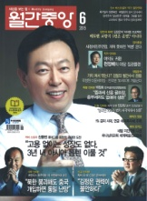
‘True Family’ to All Families of the World”
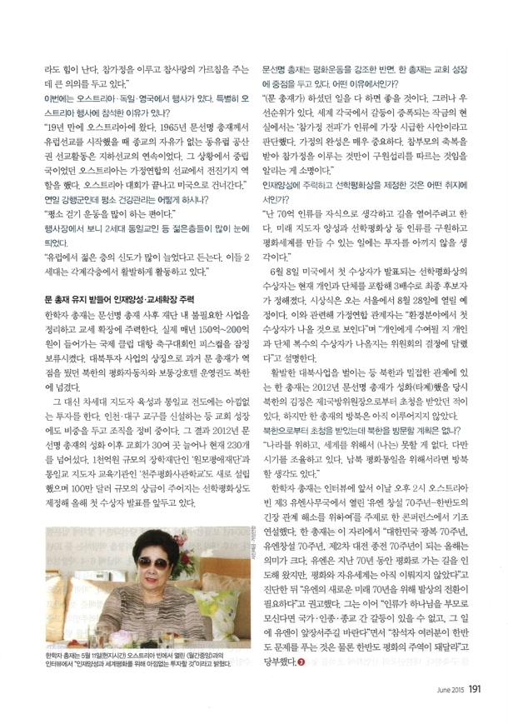
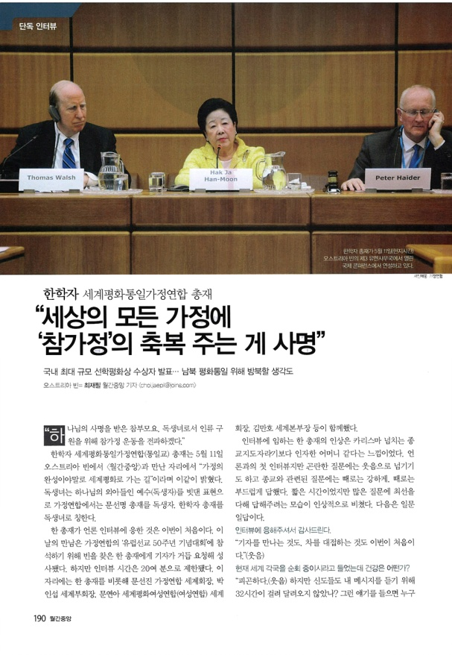

Announcement of the Recipient of the Sunhak Peace Prize,
the Largest Scale National Prize in Korea

Plans to Visit North Korea for North South Unification

“As the True Parents who have received the mission of God, and as the only begotten daughter of God, I will spread the True Family movement for the salvation of humankind.”

On May 11th, Family Federation for World Peace and Unification Dr. Hak Ja Han Moon met with the Monthly JoongAng in Vienna, Austria, to speak with us about “The Path to Peace through the Completion of the Family.” The term “only begotten daughter” was adapted from the phrase “only begotten son,” which was used to describe Jesus as God’s only son. Rev. Sun Myung Moon and Dr. Hak Ja Han Moon are referred to as the only begotten son and daughter of God within the Family Federation.

This is the first time that Dr. Han has agreed to a press interview. Although many requests have been made for interviews with Dr. Han during the event of Family Federation’s “50th Anniversary European Movement”, our interview with her lasted only about 20 minutes. Dr. Han was accompanied in her interview by Family Federation International President Sun Jin Moon, International Vice President In-Sup Park, Women’s Federation for World Peace International President Yeon-Ah Moon, FFWPU International Headquarters Director-General Man-Ho Kim and others.

Dr. Han seemed to us more like a benevolent mother than a charismatic religious leader. Although it was her first interview, she responded to difficult questions with laughter, and to religious questions with strength and grace. We were awestruck by her attentiveness to answer every question in the short time she was able to spend with us. The interview is published below.

Thank you for agreeing to an interview with us.

“This is both my first time meeting a reporter and my first time serving tea.” (Laughs)

I hear that you are in the middle of a world tour. How is your health?

“I am very tired (laughs). However, some members traveled for 32 hours to listen to my message, so I cannot help but feel energized when I think of them. It is so meaningful to be able to fulfill a true family and teach about true love.”

The events will be held in Austria, Germany and England. Is there a particular reason for your attendance of the event in Austria?

“I have returned to Austria for the first time in 19 years. Rev. Sun Myung Moon began evangelism in Europe in 1965. At the time, Eastern Europe was under Communist rule, and there was no religious freedom, so all of our evangelism was carried out underground. At that time, Austria was a neutral state, so we were able to establish a witnessing advancement center there. After our event in Austria, we are flying to the United States.”

You are on a tight schedule for many days. How are you taking care of your health?

“I take a lot of walks.”

I saw that many Unification second generation youth attended the event.

“I hear that a lot of young people joined the European church recently. They are actively working together with our second generation in many fields.”

After Rev. Sun Myung Moon’s death, Dr. Han has focused on fostering talent and increasing the congregation.

Dr. Han has also eliminated some businesses and enterprises in order to better concentrate on church growth. She temporarily postponed the Peace Cup, an international club soccer tournament which requires about 15 to 20 billion won each year in maintenance. She also entrusted the management of the North Korean investment projects (Peace Motors and the Potonggang Hotel), which Rev. Moon put a lot of focus on during his life, to North Korea.

In exchange, Dr. Han has been enthusiastically investing all of her efforts into fostering the next generation of leaders and Unification Church evangelism. New church centers have been established in Incheon and Daegu region, and greater focus is being put into church growth. As a result, since the Rev. Moon’s Seonghwa in 2012, about 30 new churches have been established, bringing the total number of churches in Korea to over 230. She also newly established the “Wonmo Pyeongae Foundation,” a scholarship organization worth 100 billion won, and the Universal Peace Academy. She established the million-dollar Sunhak Peace Prize as well, with plans to announce its first recipient this year.

While Rev. Sun Myung Moon focused mainly on peace movements, you have concentrated more on church growth. Could you explain your reasoning behind this decision?

“I would like to finish all of [Rev. Moon’s] work. However, there is an order of priority that needs to be followed. I decided that the most important thing for this world, in which conflict begets conflict, was the spread of the true family. The completion of the family is crucial. My mission is to expand the teachings of the providence of restoration, which professes the fulfillment of the true family through the blessing of True Parents.”

What is the purpose of your focus on fostering young talent and the establishment of the Sunhak Peace Prize?

“I think of the seven billion people of the world as my own children. I want to guide them. I plan to do my utmost to save all of humankind and create a peaceful world through the fostering of leaders and projects such as the Sunhak Peace Prize.”

On June 8th, the three candidates (individuals or organizations) for the first Sunhak Peace Prize will be announced. The awards ceremony will be held in Seoul on August 28th. “The first recipient will most likely be someone in the field of environment preservation,” said a Family Federation recipient. “Whether the award will go to an individual or be split between and organization and an individual is up to the award council.”

Dr. Han, who manages a close relationship with North Korea and several businesses in the nation, was invited by Chairman of the National Defense Kim Jong Un in 2012, around the same time as Rev. Sun Myung Moon’s Seonghwa (passing). However, she has not yet been able to follow through on the invitation.

You were invited to visit North Korea. Do you have any plans to visit in the future?

“Nothing is impossible for me to live for the sake of the nation and the world.
However, I am waiting to get the timing right. If it is for the sake of peace and unification between North and South Korea, I would like to visit North Korea. I hope to give you some good news regarding the matter shortly.”

Before our interview, Dr. Hak Ja Han gave the keynote address at the “The UN at 70: Toward a Resolution of Tensions on the Korean Peninsula” conference held at 2:00 PM in the UN Office in Vienna, Austria. “This year marks the 70th anniversary of many historical milestones: the restoration of Korean independence, the establishment of the United Nations and the end of World War II. The United Nations has led the way over the last 70 years in the path towards peace, and yet we still have been unable to establish peace or a world of freedom,” said Dr. Han. She then warned the UN that they needed to “change their mindset in order to continue for another 70 years.” “If all of humankind attends God as their parent, it will be impossible for dispute to exist between nations, races and religions. I hope that the UN can lead the way in making this possible.” She continued, “I hope that all of you can help us not only to solve the problems of the Korean Peninsula, but to transform it into a region of peace.”

Photo Captions

Dr. Hak Ja Han Moon gives the keynote address at an international conference held at the UN Office in Vienna, Austria, on May 11th.

Dr. Hak Ja Han Moon reveals that she plans to “invest fully in fostering talent and world peace” during her interview with The Monthly JoongAng on May 11th in Vienna, Austria.

Family Federation for World Peace and Unification Holds Celebration of
50 Years of European Evangelism Yesterday and Today

The History of the ‘Providence of Salvation’ Receives Acknowledgement from Christianity’s Head Temple
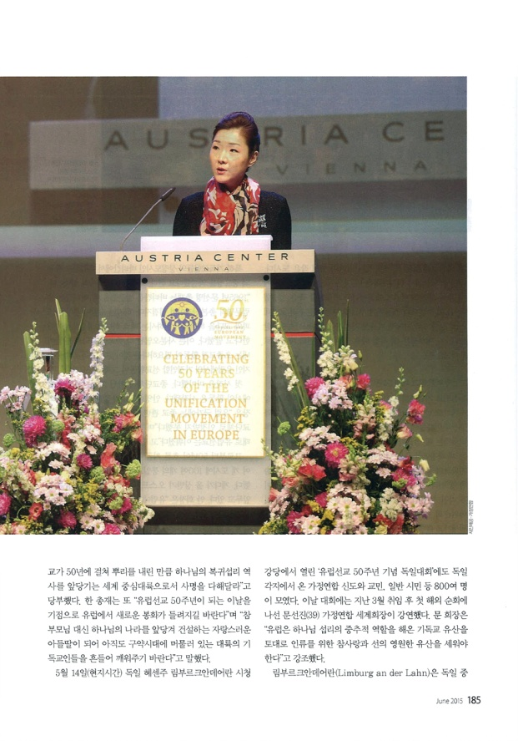
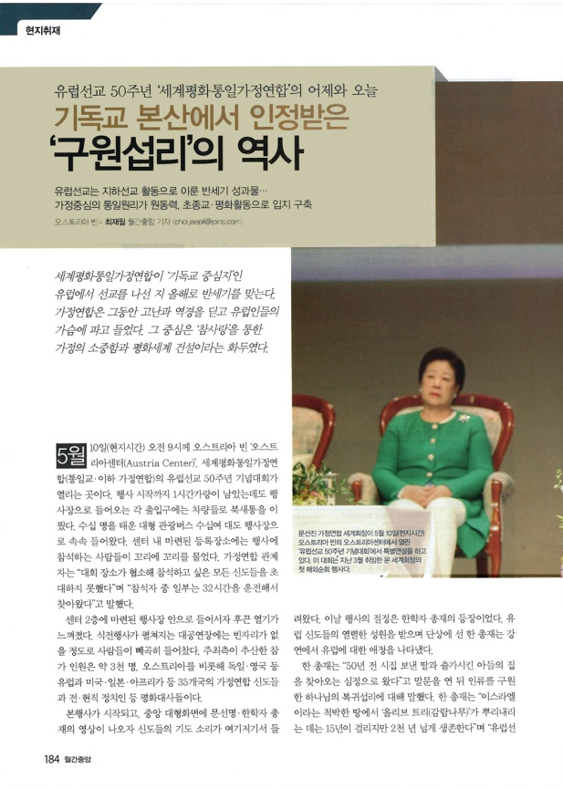

The fruits of the European underground evangelism movement after 50 years

The family is the central and driving force of the Unification Principle. The organization carved a place for itself through interreligious and peace movements

This year marks 50 years since the Family Federation for World Peace and Unification began evangelism in Europe, the “Capital of Christianity.”

The Family Federation worked for half a century through hardship and suffering to make their way into the hearts of the European people. The central teaching of their movement is the preciousness of the family and the construction of world peace through true love.

It is 9:00 AM on May 10th at the Austria Center in Vienna, Austria. The Family Federation for World Peace and Unification (Unification Church, hereafter referred to as Family Federation) has gathered to celebrate 50 Years of Evangelism in Europe. The entrances to the center were bustling with people even an hour before the event. Dozens of tour buses arrived bearing hundreds of people, and long lines formed in front of the registration tables. “The event venue was too small for us to be able to invite all of our members,” said one Family Federation representative. “Some of the participants today drove for 32 hours to be here.”

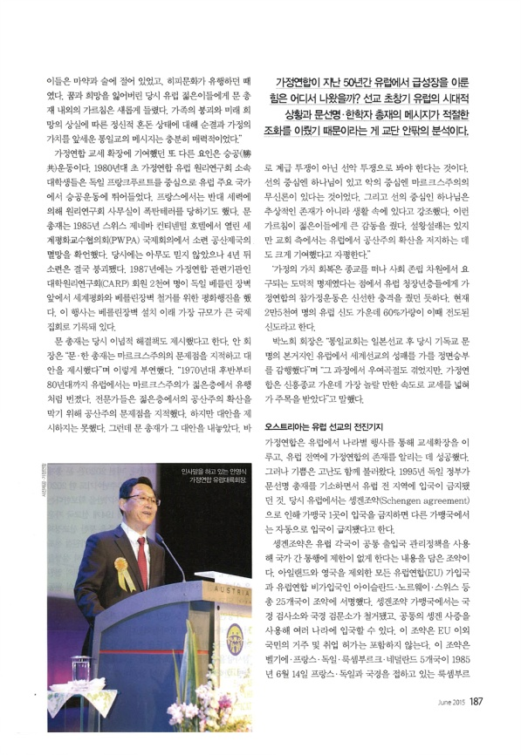
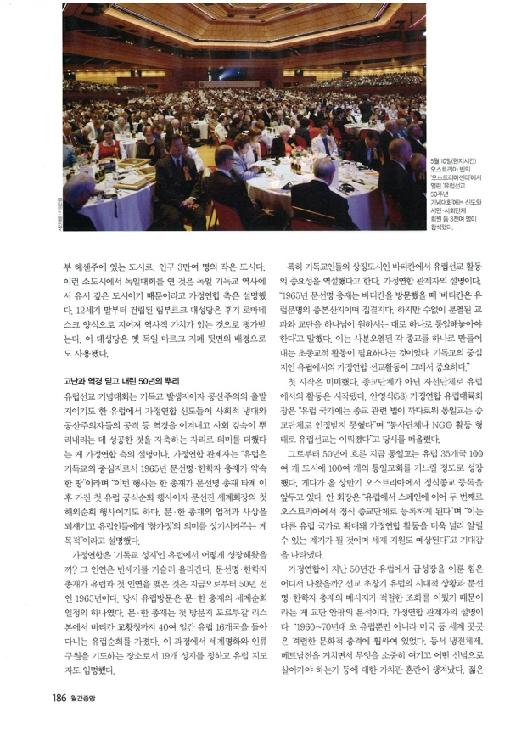

The 2nd floor of the center was alive with a bustling heat. The auditorium was completely filled for the event before the ceremony. The host organization estimated the total amount of participants to be around 3,000 members, current and former politicians and ambassadors for peace from 35 nations, including Austria, Germany, England, the United States, Japan and Africa.

As the main event began, a video about Rev. Sun Myung Moon and Dr. Hak Ja Han Moon began playing on the central screen, and the voices of members praying could be heard here and there throughout the venue. The peak of the event was the entrance of Dr. Hak Ja Han Moon. As she received the enthusiastic support of the European members, she expressed her affection for Europe through her lecture from the platform.

“I feel as if I have come to visit my son or daughter, who I married off 50 years ago,” she opened. She then spoke about the salvation of humankind and God’s providence of restoration. “It takes about 15 years for an olive tree to put down roots in the infertile soil of Israel, but it lives for over 2,000 years,” said Dr. Han. “I hope that after 50 years of putting down your roots, Europe as well will be able to become a pivotal continent in the mission of fulfilling God’s providence of restoration. “I hope that today, which marks the 50th anniversary of evangelism in Europe, you can light a new beacon fire for your continent. Please become proud sons and daughters, who can lead the way in constructing the nation of God representing true parents, and shake and wake up the Christian people of your continent who are still living in the Old Testament Age.”

On May 14th, at the Limburg an der Lahn Hessen City Hall in Germany, the “50th Anniversary European Movement German Celebration” was held to a crowd of about 800 Family Federation members. On this day’s event, Family Federation International President Sun Jin Moon, who was recently appointed this March, and is currently carrying out a world tour, gave the keynote address. “Europe needs to establish an eternal legacy of true love and goodness upon the foundation of Christianity, which has played a pivotal role in the providence of God,” she said.

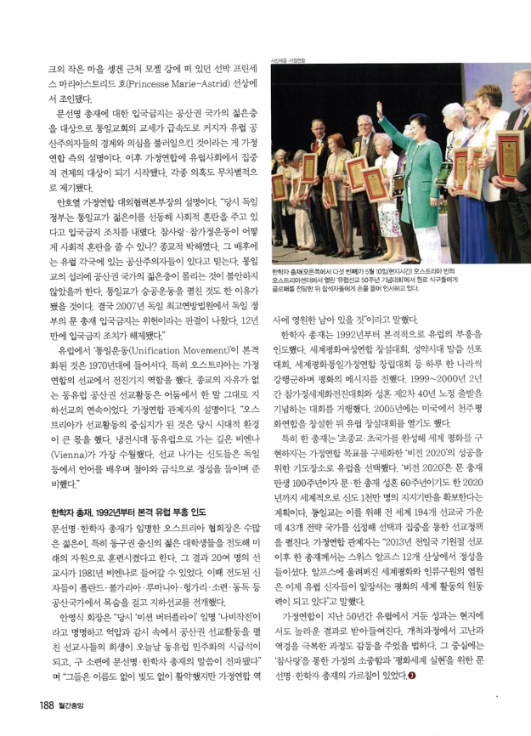

Limburg an der Lahn is located in Hessen, a small city in Germany with a population of about 30,000 people. The Family Federation explained that they held the German event in such a small city because the city itself played a very significant role in German Christian history. The Limburg Cathedral, built in the late 12th century, was constructed in the late Romanesque style, and bears a deep historical significance. The cathedral is also shown on the German Mark, the former national currency.

The Family Federation explained that the day’s events were especially meaningful as they were in celebration of victory over social persecution and attacks by Communism. The Family Federation was able to put down its roots in Europe, the birthplace of Christianity and Communism, after 50 years of conflict. “Europe, the capital of Christianity, was the promised land to Rev. Sun Myung Moon and Dr. Hak Ja Han Moon, who arrived there in 1965,” said a Family Federation representative. “This is Dr. Han’s first official tour and event in Europe since her husband’s passing, as well as International President Sun Jin Moon’s first international tour. As we meditate upon the accomplishments and teachings of Rev. and Dr. Moon, we hope to remind the European people of the meaning of ‘true families.’”

How was the Family Federation able to grow in Europe, the “Holy Land of Christianity?” It was a 50- year uphill battle that began in 1965, when Rev. and Dr. Moon first visited Europe on their world tour. They visited 16 European nations over 40 days, including Lisbon, Portugal and the Vatican. During the tour, 19 new holy ground sites were established as places to pray for world peace and the salvation of humankind and new European leaders were appointed.

“Rev. Moon emphasized the importance of the European evangelist movement in the Vatican, the symbolic city of Christianity,” explained one representative of the Family Federation.

“In 1965, when Rev. Sun Myung Moon visited the Vatican, he said that ‘The Vatican is the origin of and the place of assembly of European civilization. However, we must unite all of the countless divided denominations and sects and unite them in the way God desires.’ We need interreligious movements in order to unite the religions as one. This is why it was so important for the Family Federation to evangelize Europe, the capital of Christianity.”

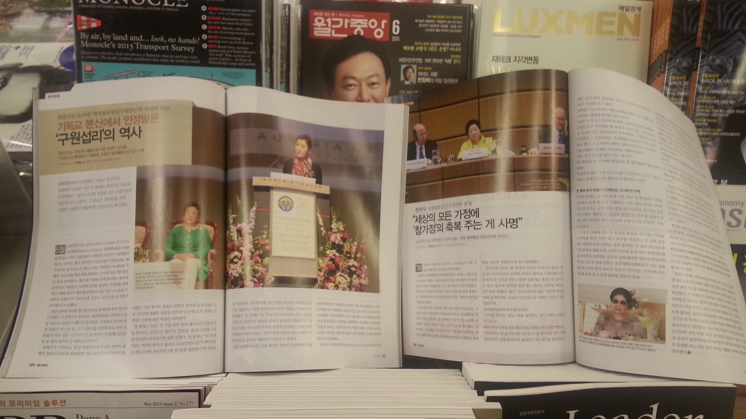

The movement in Europe had humble beginnings, as a charity organization rather than a religion. “A lot of very complicated laws regarding religion existed in Europe, so the Unification Church was unable to be recognized as a religion,” reflected Family Federation European Regional President Young-Sik An (58). “We began our evangelist movement in Europe as a non-governmental organization that did service work.”

50 years later, the Unification Church has established about 100 churches in 100 cities throughout 35 European nations. Furthermore, soon Austria will register the Unification Church as an official religion. “Spain was the first nation in Europe to recognize us as an official religion, soon to be followed by Austria,” said Director An. “We plan to continue to expand to other European nations, to spread our name and receive tax support as well.”

How was the Family Federation able to achieve such rapid growth in just 50 years? People both within and outside of the movement believe that the message of Rev. Sun Myung Moon and Dr. Hak Ja Han Moon matched the climate of Europe at the time of early evangelism. “In the 1960s and 1970s, Europe, America and many other places in the world were thrown into a state of intense cultural shock. While faced with the problems of the Cold War and the Vietnam War, people were unable to distinguish what was truly important and by which principles they should conduct their lives. The hippie culture, in which young people immersed themselves in drugs and alcohol, became very popular at this time. The teachings of Rev. and Dr. Moon were a new beginning for many European youth, who had lost their dreams and hopes at that time. The teachings of purity and family values drew many people to the Unification Church in an era of spiritual chaos, family breakdown and loss of hope for the future,” explained a representative of the Family Federation.

One of the main factors that led to the growth of the Family Federation was the movement for victory over Communism. In 1980, university students of the early Family Federation, known at that time as the Collegiate Association for the Research of Principles(CARP), carried out movements against Communism in Frankfurt, Germany and other major European countries. In France, an opposing group planted a bomb in the CARP office. In 1985, Rev. Moon predicted the fall of the Soviet Union at the Professors for World Peace Academy International Conference, held at the Continental Hotel in Geneva, Switzerland. No one believed his prediction at the time, but four years later, the Soviet Union finally collapsed. In 1987, about 2,000 members of the CARP (an affiliate of the Family Federation) held a march for peace in front of the Berlin Wall, calling for the wall’s destruction and for world peace. It was recorded as the largest-scale international gathering since the construction of the wall.

Rev. Moon also outlined ideological solutions to problems of that time. “Rev. and Dr. Moon pointed out the problems of Marxism and outlined alternative options,” said Continental Regional President Young-Sik An. “Between the 1970s and 1980s, Marxism was very popular among young people in Europe. In order to block the further spread of its popularity, specialists of the time began to point out the shortcomings of Communism, but no one gave an alternate option except for Rev. Moon. He revealed that it needed to be seen as a battle between good and evil, rather than as a battle between classes.

He alluded that God was at the center of goodness and the atheism of Marxism was at the center of evil. Rev. Moon also emphasized that God was not an abstract idea, but rather an actual being. His teachings deeply moved the young people. There is much argument about this topic, but the church regards Rev. Moon’s teachings as a strong factor in foiling the growth of Communism in Europe.”

The “Resurrection of Family Values” movement was carried out on a social level, rather than a religious level, and proposed a moral reform that appealed to young and middle aged Europeans, and revived the true love movement. Out of approximately 25,000 European members, an estimated 60% joined the movement at this time.

“After the Unification Church evangelized Japan, it took on Europe, the center of Christian civilization. Our success in evangelizing the world depended on our success in Europe,” said President No-Hi Pak. “We went through some complications, but in the end, the Family Federation gained a lot of attention for becoming the fastest growing new religion in Europe.”

With Austria as their evangelism advancement base, the Family Federation carried out events in many different nations in Europe, expanded their congregation and succeeded in making their name known throughout the continent.

However, suffering followed their success. In 1995, the German government indicted Rev. Moon and banned him from entering Germany. Due to the Schengen Agreement, if one nation banned a person from entry, all other countries in the treaty needed to follow suit.

The Schengen Agreement was arranged so that all of the immigration laws of the European nations would coincide, making it easier to move between nations without limitations. 25 nations, including those of the European Union and Iceland, Norway and Switzerland, and not including any islands or the United Kingdom, signed the agreement. Participating nations in the treaty had their border inspection offices and checkpoints destroyed, and through obtaining a common Schengen visa, one could move freely between many nations. The agreement did not include citizens living outside the EU or give any person permission to work within the union. The treaty was signed on June 14th, 1985 by Belgium, France, Germany, Luxembourg and the Netherlands, on the boat Princess Marie-Astrid, on the Moselle River in the small town of Schengen, Luxembourg, a nation that borders France and Germany

The Family Federation explains that the rapid growth of their congregation, and especially its concentration of young people, aroused suspicion in the Communist nations of Europe. They attribute the prohibition of Rev. Moon’s entry into the continent to this fact. Afterwards, the Family Federation faced persecution from European society.

“The European government banned Rev. Moon from entering the country because of the flame the Unification Church ignited amongst the young people. They said we were creating social chaos, but how can a true love and true family movement possibly create social chaos? It was religious persecution. I believe that the Communist nations of Europe were behind the decision. Perhaps they were becoming uneasy that so many of their young followers were leaving them to follow us, or perhaps it was because of our victory over Communism movement. Eventually, in 2007, the Federal Constitutional Court of Law ruled the German government’s ban of Rev. Moon as unlawful. The 12-year ban was finally lifted,” said Public Relations General Manager Ho-Yeul An. The “Unification Movement” began in earnest throughout Europe in the year 1970. Austria played a particularly pivotal role in the evangelization of Europe. With one word, the underground evangelization of the religiously oppressed, Communist Eastern Europe continued. “Austria played a huge part in our movement to evangelize Europe. At the time of the Cold War, the easiest way to enter into Eastern Europe was through Vienna. Our members, who would go out to witness, would learn German and other European languages and fast and pray all night to prepare,” said a Family Federation representative.

Dr. Hak Ja Han Moon Brings European Revival in 1992

The Family Federation President of Austria, appointed by Rev. and Dr. Moon, witnessed to countless young people, especially many university students from Eastern Europe. As a result, in 1981, about 20 evangelists were able to enter into Vienna. At the time, members from Poland, Bulgaria, Romania, Hungary, the Soviet Union, East Germany and other Communist nations were risking their lives to carry out underground evangelism activities.

“We called the mission ‘Operation Butterfly.’ The sacrifice of those evangelists, who worked against persecution and surveillance in Communist nations, brought about the eventual democratization of Eastern Europe, and brought Rev. and Dr. Moon’s teachings to the Soviet Union,” said Regional President Young-Sik An. “Though those evangelists worked anonymously in the dark, they will be immortalized throughout Family Federation history.”

In 1992, Dr. Hak Ja Han Moon brought about the European revival in earnest. She spread the message of peace and carried out the Women’s Federation for World Peace Foundation Rally, the Proclamation Rally for the Completed Testament Age and the Anniversary Rally for the Family Federation for World Peace and Unification, all in consecutive days. Between 1999 and 2000, the True Family World Advancement Rally and the Holy Wedding Ceremony 2nd 40 Years Course Dedication Ceremony were held, and in 2005, the Universal Peace Federation was established in the United States, followed by a European foundation rally.

Dr. Han especially chose Europe as a place to substantiate the Family Federation’s motto to “create a world of peace by bringing nations and religions together,” and as a place of prayer for the success of Vision 2020. The year 2020 marks 100 years since the birth of Rev. Moon and 60 years since his and Dr. Han’s holy wedding. Vision 2020 seeks to create a foundation of support of 10,000,000 followers around the world by that time. In order to carry out this mission, evangelization strategies are being carried out in 43 key nations of the 194 evangelized states of the Unification Church. “After the announcement of Cheon Il Guk Foundation Day in 2013, Dr. Han climbed to the top of 12 mountains in the Swiss Alps, where she poured out her heart in devotion. Her hopes for the salvation of humankind and world peace echoed throughout the Alps, and became the stimulus for the European members to lead the way in the movement for world peace,” said a Family Foundation representative.

The fruits of the last 50 years of the Family Federation in Europe are truly moving, especially when considering the suffering overcome during the years of pioneering. Rev. Sun Myung Moon and Dr. Hak Ja Han Moon’s teachings about the preciousness of the family and the fulfillment of a peaceful world through true love are at the center of those years of pioneering.

How was the Family Federation able to achieve such rapid growth in just 50 years? People both within and outside of the movement believe that the message of Rev. Sun Myung Moon and Dr. Hak Ja Han Moon matched the climate of Europe at the time of early evangelism.

Photo Captions

Family Federation International President Sun Jin Moon gives the special keynote address at the “50 Years of European Evangelism” celebration held at the Austria Center in Vienna, Austria on May 10th. This is President Moon’s first international tour since taking office in March.

The “50 Years of European Evangelism” event, held at the Austria Center in Vienna, Austria on May 10th, was attended by about 3,000 followers, citizens and members of social organizations.

Family Federation European Regional President Young-Sik An gives greeting remarks.

Dr. Hak Ja Han Moon (fifth from the left) shakes hands with and greets participants after awarding elder members with certificates of merit at the “50 Years of European Evangelism” celebration held at the Austria Center in Vienna, Austria on May 10th.

